PWCS VHS | Name:

Module III: Ancient Egypt
Directions: Read the background essay and analyze the five primary sources below. These will help you discover how the Nile shaped Ancient Egypt. Type your responses directly in this document, save the file (III.2_LAST NAME) and submit it to the dropbox.
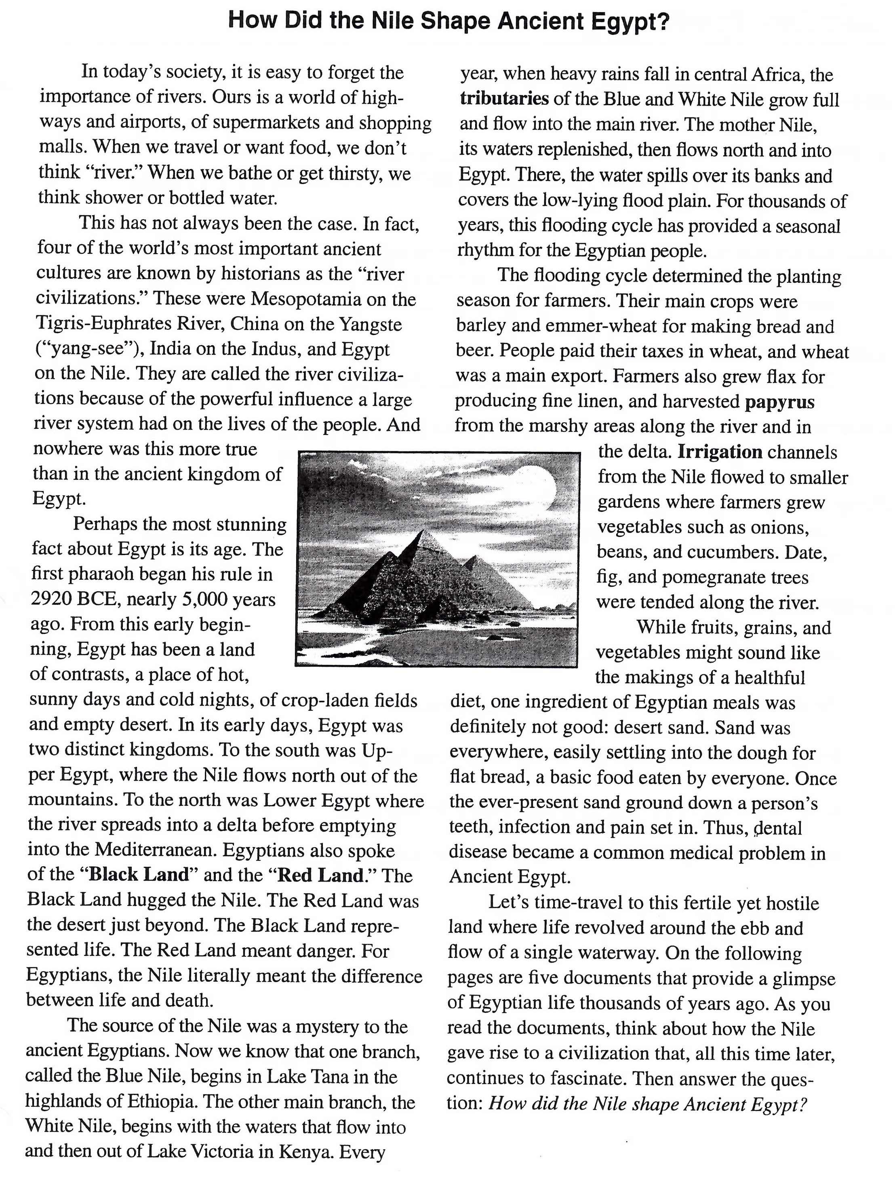
Document A
(Source: Map created from various sources)
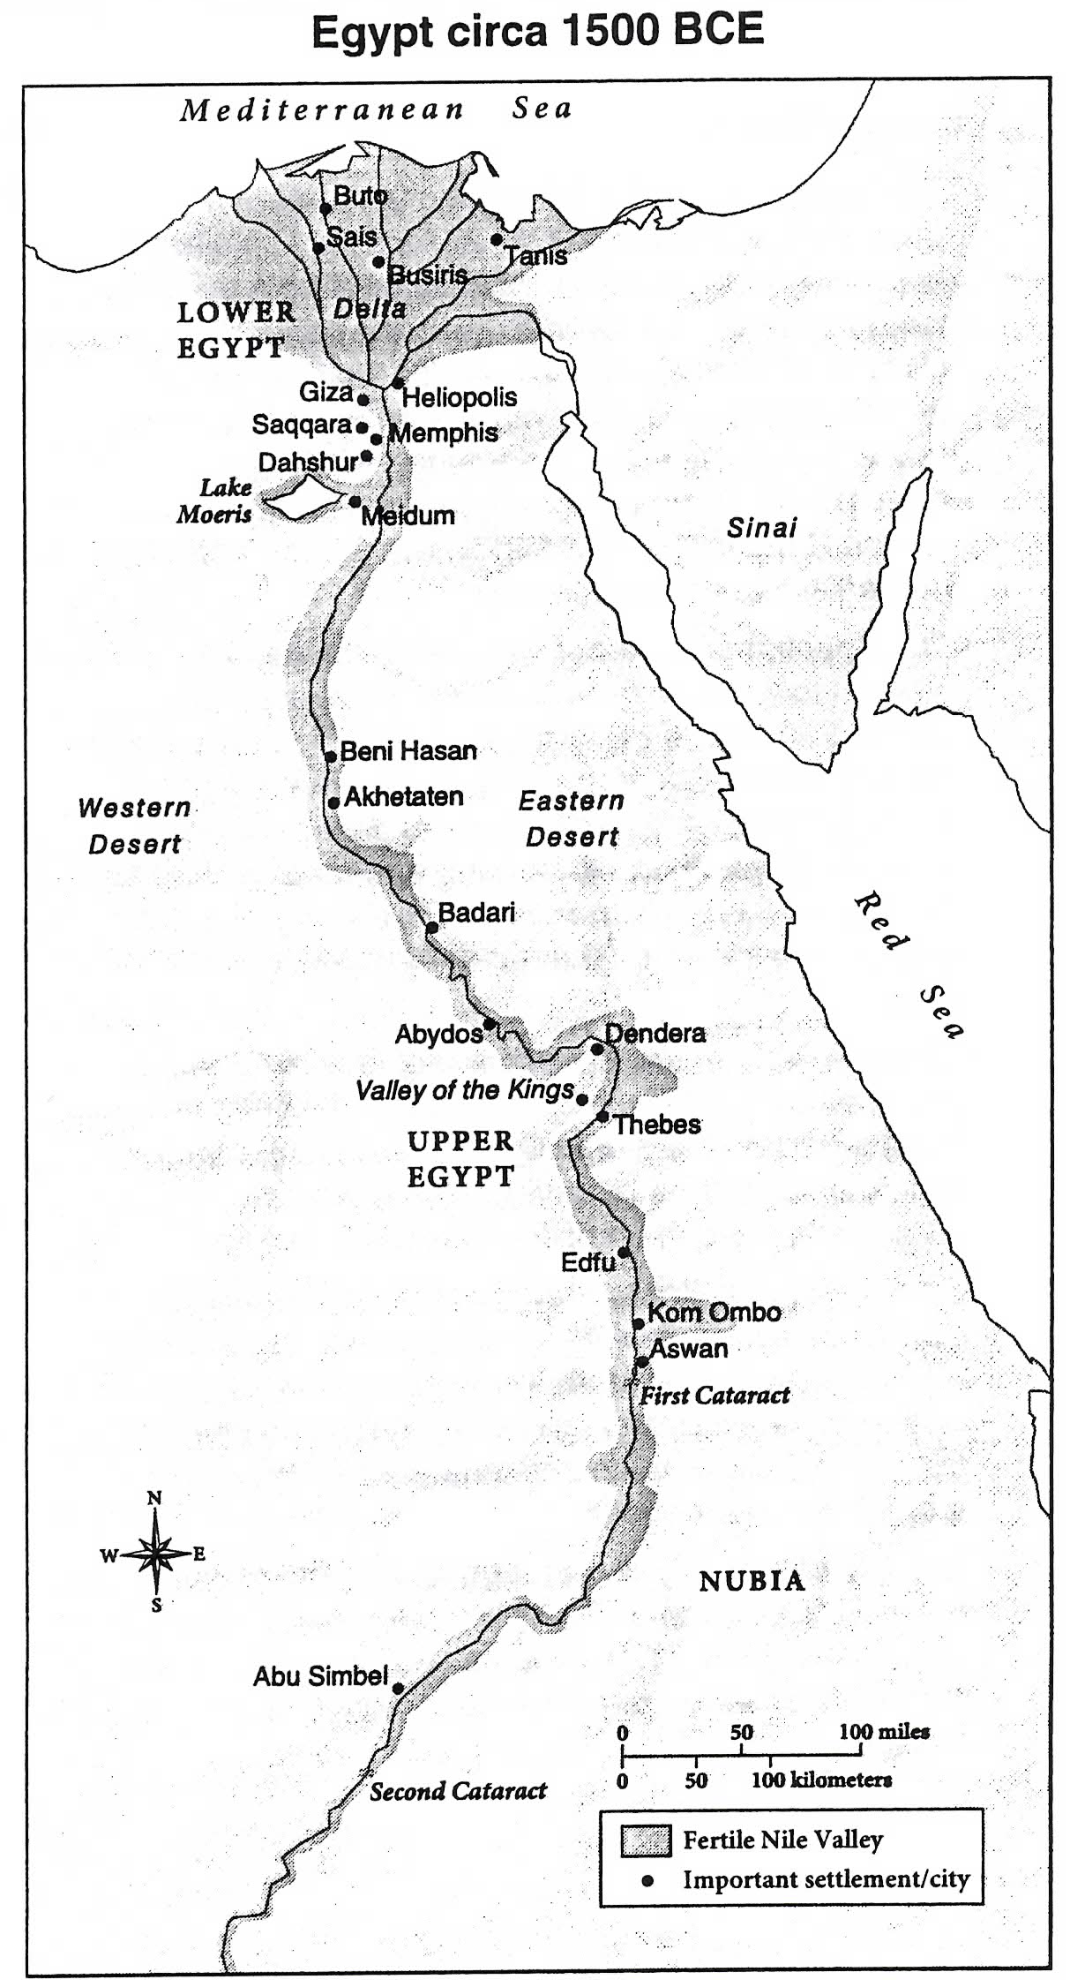
Document Analysis
- The Nile is the world’s longest river, 4,160 miles. Consider the southern boundary of Ancient Egypt to be at Aswan (the first cataract, or rapids). About how many miles of the Nile are actually in Egypt?

- Why is the delta region to the north called “Lower Egypt”?

- What were the eastern, western and northern boundaries of Egyptian settlement?

- Given the geography of this area, do you think Egypt was vulnerable to foreign invaders? Explain your thinking.

- What do you notice about population distribution and settlement location in Ancient Egypt? List three or four reasons for this.

Document B
(Source: Chart adapted from Katherine Hinds, Life in Ancient Egypt: The Countryside, Marshall Cavendish Benchmark, 2007.)
The Nile River Flood Cycle
Akhet (flood season)  Mid-June to mid-October | Fields in the Nile floodplain covered in water and fertilized by a new batch of silt. Time when many farmers worked off their public-labor tax, doing jobs like canal repair or quarrying.
Peret (planting and growing season)  Mid-October to mid-February | Water receded but Nile high enough to fill irrigation canals, crops planted and tended.
Shemu (harvest season)  Mid-February to mid-June | Crops in the Lower Nile harvested and sent to market.
Note: The average rainfall, historically and today, has remained about the same. The Nile delta receives about four inches per year. The Nile Valley south of Cairo receives less than one inch. In comparison, Atlanta, GA, gets about 50 inches of rain annually and Phoenix, Arizona, about eight inches.
Document Analysis
- What differences do you see between Egyptian seasons and the standard seasons in much of the United States today?

- Usually the flood season produced a “good Nile,” just the right amount of water. What might be the consequence of a “bad Nile” – too much or too little water?

- The population of Ancient Egypt was probably about one million, 95 percent of whom were farmers. According to the chart, when were farmers busiest?

- When would this large work force of farmers be available to work on government projects, like building palaces and tombs?

Document C
(Source: Illustration by Oliver Frey in Living in Ancient Egypt, Norman Bancroft Hunt, editor, Thalamus Publishing, 2009.) 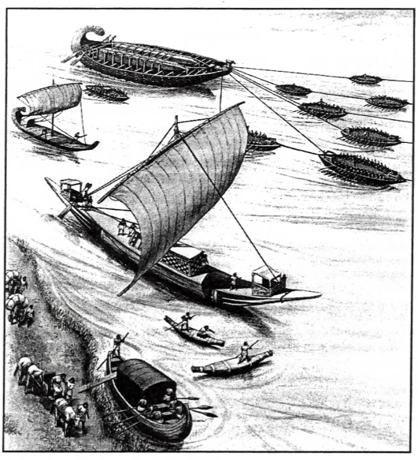
Note: The Nile River flows south to north against the prevailing northerly wind. In ancient times, boats traveling upstream against the Nile current used a sail or rowers or both. Boats traveling downstream to the north often just floated with the help of steering oars. The Nile current was about four knots (4 mph) during flood season. It slowed to a sluggish one knot (1 mph) during the rest of the year.
Document Analysis
- What is being transported by the barge (the vessel pulling the tugboats)?

- What is likely being carried by the large sailboat?

- What direction are the sailboats, barge, and tugs traveling? Explain your reasoning.

- Drawing from evidence in the document, what are five occupations in Egypt that depended in some way on the Nile River?

Document D
(Source: Painting from the tomb of a tradesman named Sennedjem, who lived sometime between 1307 and 1196 BCE.)
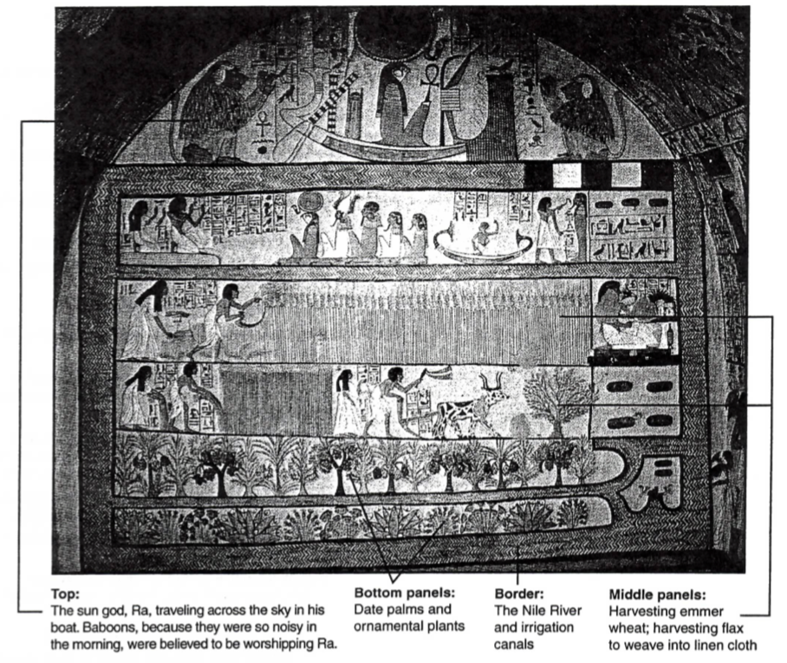
Note: The afterlife in Ancient Egypt was a paradise called the Field of Reeds, shown in this tomb painting. Those whose heart had the correct weight at death could, after a long journey, live in the Field of Reeds forever. The Field of Reeds was believed to be somewhere in the east, near the rising sun.
Document Analysis
- The middle panels of this tomb painting show the deceased and his wife engaged in various activities. What kind of activities are they?

- What natural and man-made objects can you identify in the bottom three panels?

- What would disappear from this picture of paradise if the Nile weren’t present?

Document E
(Source: From the song “Hymn to the Nile,” circa 2100 BCE.)
Hail to you, oh Nile,
spring from the ground, come to keep the land alive…
who floods the fields that Ra [sun god] has created
to make all the animals live…
who produces barley and makes wheat grow,
that the temples might be in festival.

If he is sluggish, noses suffocate,
everyone is impoverished…
If he rises, the land is exultation,
and everyone is in joy.

Document Analysis
- What is a hymn?

- According to the “Hymn to the Nile,” why do the Egyptian people praise the river?

- What is the one “bad” behavior of the river that is mentioned? What is the result?

- The famous Greek historian Herodotus once wrote that “Egypt…is, so to speak, the gile of the Nile.” What did he mean and was he right?

